When converting a word equation to a formula equation.
- Metals. For metals we just write the symbol on its own.
Name | Symbol
Iron
Calcium
Silver
Lithium
- There are some formula that we need to know.
 | Name | Formula
The diatomic gasses | Oxygen gas | O₂
The diatomic gasses | Nitrogen gas | N₂
The diatomic gasses | Hydrogen gas | H₂
The diatomic gasses | Chlorine gass | Cl₂
 | Carbon dioxide | CO₂
 | Water | H₂O
 | Carbon | C

- The acids
Hydrochloric Acid HCl
Nitric Acid HNO₃
Sulfuric Acid H₂SO₄
Phosphorous Acid H₃PO₃
- For ionic compound we work out the formula by using the drop and cross method.
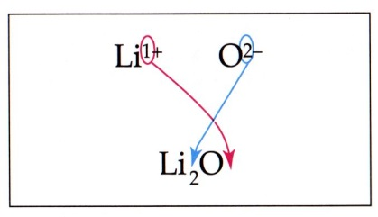

Calcium metal + oxygen gas calcium oxide

Hydrogen gas + chlorine gas hydrochloric acid

Iron metal + hydrochloric acid iron chloride +hydrogen gas

Lead metal + oxygen gas Lead oxide

Calcium metal + water calcium hydroxide and hydrogen gas

Chlorine gas + lithium metal lithium chloride

Silver metal + hydrochloric acid silver chloride and hydrogen gas

Carbon + lead oxide carbon dioxide + lead metal

